Term 3 has been one of significant momentum for the college. School Review across week 6 provided a great opportunity to showcase the college, and the efforts of students and staff. The feedback from the School Review team was very positive and when the final report is available, we will share it with the Canberra College community.
In this issue
Arty Bits
CLASS
Mathematics
Science
Wellbeing
Get Involved at CC
Student Services
Futures
Humanities
PE
CCCares
Important dates for term 4

September 2019 NEWSLETTER
Principal’s Update
We have thanked staff and students for their contributions, and now we undertake the task to establish a new five-year School Improvement Plan for the college. Early in term 4 we will invite consultation from our community so please consider advice you may like to share to influence the planning process and outcome. As a progressive and inclusive government college, by emailing CanberraC.Info@ed.act.edu.au we welcome your ideas and feedback to support continuous improvement.
The Year 11 and 12 Parent Teacher Interviews are 4.30-6.30pm on Tuesday 24 September, conducted in the ASGARD Theatre and the adjacent Humanities area. Mid-semester progress reports were emailed to parents and carers recently and provided details to make your bookings through the online portal.
The recent Year 12 AST ran very well with approximately 300 students involved. I witnessed many smiles of relief and/or success leaving the sessions, so I hope the cohort has done well. In parallel the Year 11 students completed AST trials and for the first time, where possible, other classes were conducted for students not involved with either AST assessments. The learning for all at CBRC prevailed through AST!
2020 Year 11 enrolment acceptances are continuing to be processed and we anticipate another cohort of approximately 450 at this stage. It is great also to note that 96% of acceptances have utilised the opportunity to make first stage course selections through the online facility. This timely information informs our curriculum and class offerings for 2020. Early in term 4 all prospective Year 11 students will be interviewed about their course selections at their local government High School by our Transition Team. All other students will be able to attend their interview at the college in week 3. Details have been sent to each student. Please contact the college if you need further information.
This term 3 newsletter celebrates some amazing achievements across academic, arts, cultural and sporting pursuits and I strongly encourage you to go beyond my message and get to know more about the opportunities at Canberra College.
If you also follow Canberra College on Facebook, along with 2000 other followers, you will have enjoyed a timeline of success this term in many forms including the recent Limelight Performing and Visual Arts events, news of our very own snowsport champion, Amber Essex, DanceFest, Ultimate Frisbee College Champions and the Ilford Photography awards.
We also had four groups of Outdoor Education students participating in a challenging kayaking excursion on the Goobragandra River, nearby my hometown of Tumut, NSW. Canberra College certainly delivers on an amazing range of activities for a diverse and capable student population.
Finally, the upcoming school holiday break will give staff and students to enjoy the time with family and friends and please note the important calendar dates for Term 4 at the end of this newsletter. (Note that public schools commence Term 4 on Monday 14 October)
Wishing all an enjoyable Spring break. A great time to check out Floriade.

Michael Battenally
Principal

Parent/Teacher Evening Tuesday 24 September 4:30-6:30pm

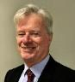
Melissa Planten
Michael Battenally
Jan Marshall
Chris Brown
Deputy Principal
Deputy Principal
Deputy Principal
Principal

Arty Bits

Step into the Limelight 2019
Limelight Art Showcase School of Art Gallery
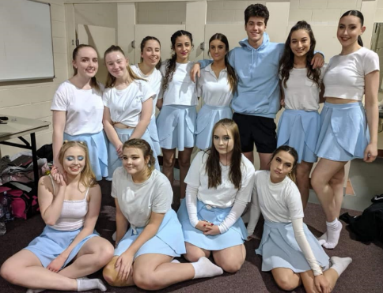
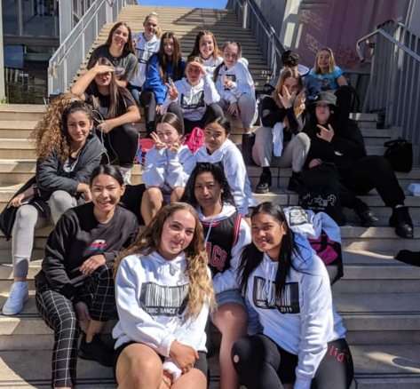
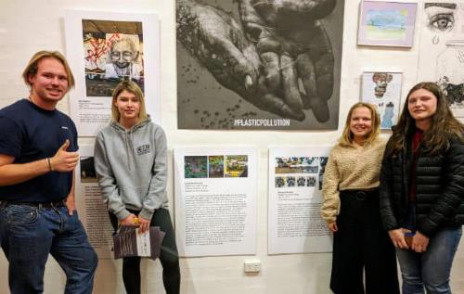
We are extremely proud of the significant involvement that we had in this year’s gala showcase at the AIS and the art exhibition at the School of Art Gallery.
Jazz Band
Dance Festival 2019
Dancers Limelight gala AIS 2019
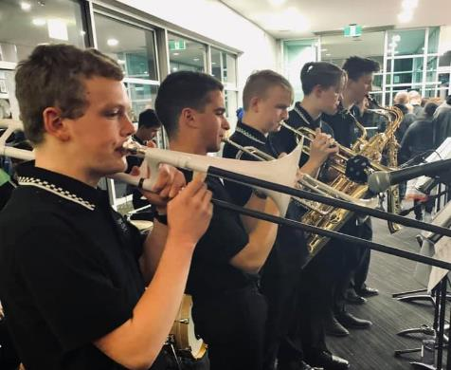
Congratulations to our visual art and photography students (and their mentoring) teachers who had beautiful work selected for the exhibition. Some of our awesome musicians were asked to provide music throughout the official event and our amazing hospitality students and staff from CCCares impressed the hundreds of guests with their catering expertise.
The gala performance showcase was held at the AIS in week 6. Our jazz band wowed the crowd for an hour in the foyer pre-show and our dance students impressed with their beautiful choreography and dance during the main performances.
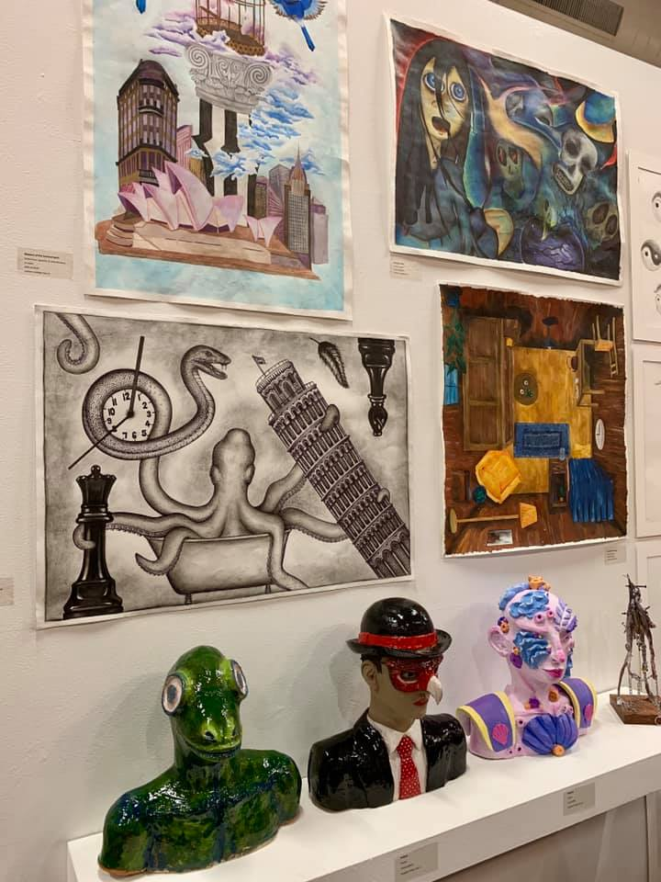
Another reason to celebrate how diverse and impressive our college students and staff are!
jazz band limelight AIS

Media
Congratulations to year 12 student James 'Jimmy' Hiscutt who filmed about the conservation of sea urchins in the 2019 Canberra Short Film Festival. The film was screened alongside international and local short films. James was the only U18 filmmaker whose work was selected in the documentary category.

Music
Three Canberra College music students are performing at the annual ACTcent Concert at Llewelyn Hall on the 18th of September.
The concert features the best music students from across all schools in the Canberra region.
Koebi, Liam and Xavier started playing together as a jazz trio early in 2019.
They have performed as a trio at several performances including the Merimbula Jazz Festival, Canberra College Music Showcase, College Open Night and Limelight Art Exhibition opening.
Koebi is a seasoned performer with his band “The Faumuis”, Liam has worked professionally as a jazz drummer and Xavier participates in the School of Music Ensemble classes.
All three are talented musicians with a passion for jazz.

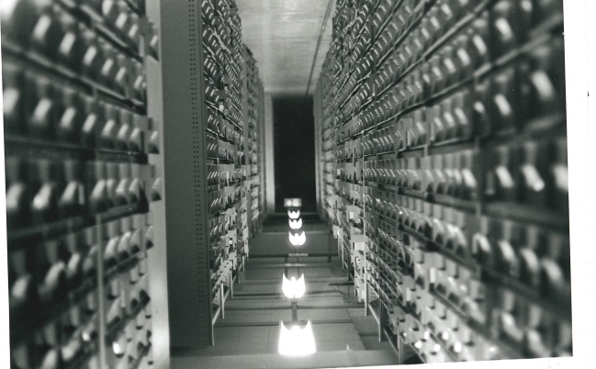
Photography
Curves of Modernism- Alice Johansson-Cranfield
Unknown - Erin Ashley
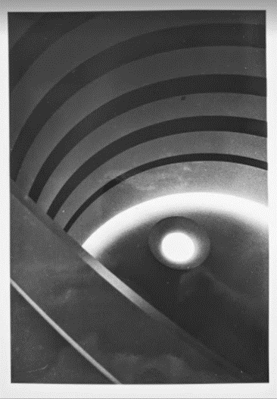
The National Gallery is starting ‘NGA Teens’, a program that enables art-led learning, engagement and experiences for our younger audiences - the next generation of artists and thinkers. Angela Van Der Riet a year 11 photography student has been selected and will represent one of a select few teenagers in Canberra. This inaugural Teen Council will assist in developing and delivering events for young audiences. Congratulations on this achievement, Angela.
CIT Creative Industries open house was on Thursday 12 September 2019, photography students Tobie, Ruby, Sabine, Bella, Hayley, Eloise and Nimi met the staff, used CIT's first-class industry standard facilities, and found out what it was like to be a CIT student for a day.
The negotiated photography unit has been working with liquid emulsion. This allows you to print photographs onto anything and everything using standard darkroom procedures. Students are printing on wood, plastic, glass and handmade paper. We are all looking forward to seeing some very creative work.
Congratulations are extended to two of our students who recently submitted work in the Ilford School’s Photographic competition term 2, 2019. Merit certificates were awarded in the silver halide year 11-12 category to Erin Ashley for her print “Unknown” and Alice Johansson-Cranfield for her print” Curves of Modernism”. Canberra College has also won second place for “Best School for the Term” category award and for this received an engraved plaque and voucher for $100 to spend on Ilford products.

Arts Industry Pathways and connections
Photo and Media students were visited by Glen Ryan in week 8. Writer, Photographer and Cinematographer. He spoke about how traditional photography is increasingly merging with videography and the importance of learning a broad base of skills (internet publishing, stills + motion, marketing, networking etc) to gain employment in the industry these days. Glen is the owner / manager of Silver Dory Productions.
Drama students will be meeting Australian film and TV actor, Liz Burch (Flying Doctors, Five Mile Creek, Ocean Girl, and Blue water High) in Week 10. Liz will be answering questions from our students about anything to do with working in the industry, audition processes and preparation and resilience to keep going in this tough performing arts industry.
The Term 3 Art Exhibition will be held in week 10 on Wednesday 25th September. See poster below.
The Drama production of AWAY by Michael Gow will be held on 15th and 16th November in the CCPAC Theatre.

Kim Walkom
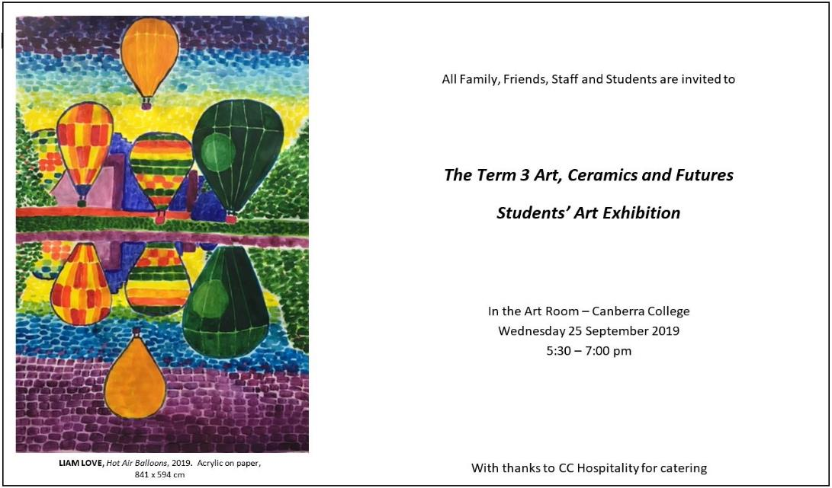
Arts Executive

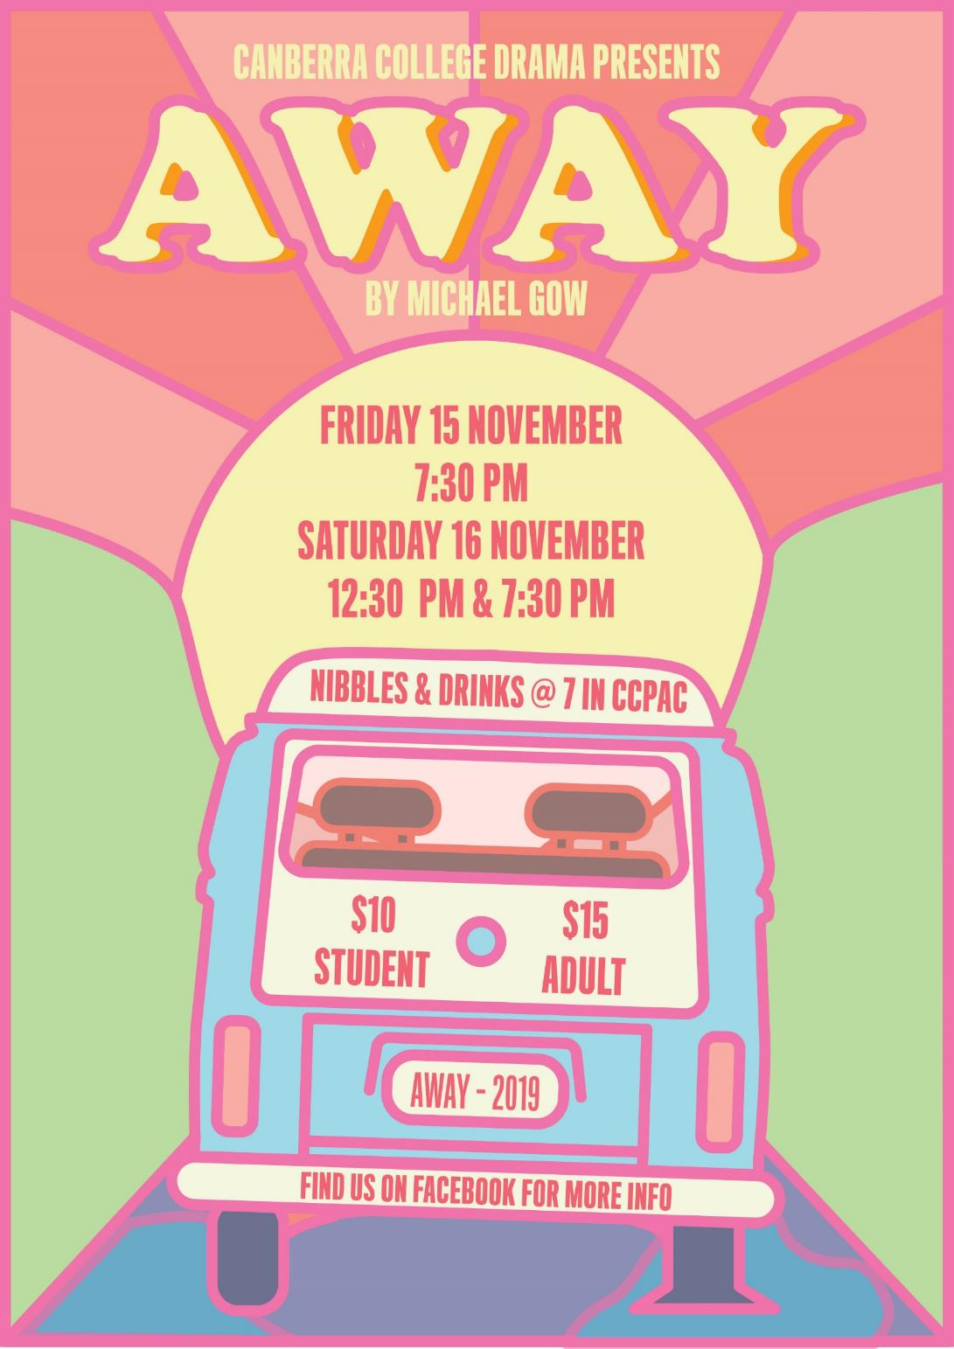
CLASS

The CLASS Faculty comprises the Commerce (Accounting, Business, Business Services & Economics), Languages (Chinese, French, German, Italian and Japanese) and Social Sciences (Behavioural Sciences [Psychology, Sociology and Social & Community Work] Global Studies and Legal Studies) courses.

Psychology – Year 11 camp Borambola, Wagga Excursion:
It was a cold and frosty morning as we packed our luggage on board the bus. David (our driver and teacher) had the heaters running on high, but it initially did very little to stop the shivering. As the day’s first light broke over the hills, we headed off to Wagga, and by the time we were ten minutes up the road, the bus had finally warmed up. Our first stop at 7.45 am was at the truck stop in Gundagai, where we filled up on hot coffee and toasty bacon and egg rolls. Unfortunately, at this stage, it was raining and miserable, but we were not going to let a little rain dampen our excitement and spirits.
Upon arriving at Camp Borambola, we were welcomed by the staff and introduced to Bree, our instructor. She took us round to the dining hall and gave all the students a safety briefing, followed by their room keys. The students were given some time to unpack, before heading back to the hall for their first psychology workshop, “Positive Psychology”. In this workshop, the students discovered the benefits of looking at psychology from a positive perspective, rather than a deficit perspective; showing that often, prevention is better than cure. We covered topics such as resilience, forgiveness and the difference between the pleasant life, the good life and the meaningful life. Two hours later, we were tucking into a hearty lunch that included wraps and a cup of hot vegetable soup.
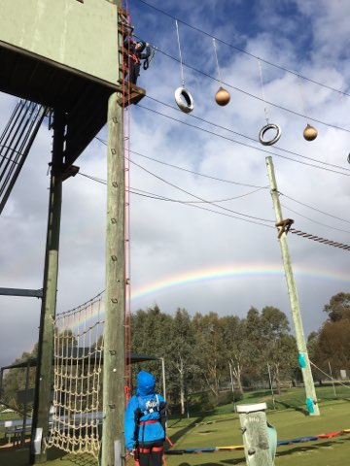
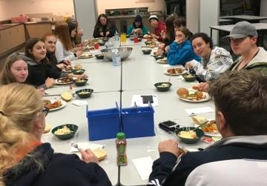
Due to some incoming bad weather forecast for Friday, we decided to switch some activities on the itinerary, so we headed out to the high ropes advanced course. Students were taken through the safety briefing and how to gear up in the harnesses; then the climbing began. The advanced course is constructed about 3 storeys up and consists of various wire obstacles across a distance of 25 metres. This was quite the challenge for many students; some had a fear of heights, whereas others had never tackled such a personal challenge. We were very proud of their efforts, and every student successfully conquered the course. This activity allowed students to discover their personal strengths, and it promoted teamwork and social support. We then headed back to the cabins to warm up, and the students were given some free time to relax. Dinner was a welcome surprise, consisting of roast pork with crackling, baked vegetables with gravy, and apple crumble and custard for desert; very yummy! Afterwards we rugged up and headed out to the bonfire, where we roasted marshmallows and played “Personality Disorder Celebrity Head”; the students really enjoyed this time together and were kept nice and warm by the crackling fire. We then headed back indoors for fruit salad, biscuits, chips and popcorn for supper, while we watched the movie, “Shrek”. As 10.30pm drew close, eyes were beginning to slam shut, so we stopped the movie and headed off for a well-deserved sleep.
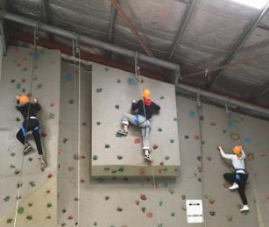
Friday began with a hot breakfast at 8 am, followed by 2 hours of rock-climbing; thankfully this was run inside the gym, and we were protected from the elements. Outside it was very cold and windy, and by 11.30 am we were down at the archery range, shivering with an ambient air temperature of just 4 degrees! Yes, we were all cold, but the distraction of competitively trying to hit a bullseye was enough to keep us warm. After chicken and salad wraps for lunch, the afternoon comprised of our Lifeline workshop, “Shut Up and Listen”, where students acted out crisis scenario’s on story cards, and learnt how to verbally react to someone who is having a tough time. The skills they took from this workshop are invaluable and many commented on what a great workshop it is for adolescents. By 2.30 pm we were saying thank you and goodbye; we grabbed our luggage, boarded the bus and hit the road headed for Canberra. Most of the trip home consisted of an 80’s music sing-along, which was great fun; we were very surprised that the students knew the words to so many songs that were from our (teachers) era and not theirs! After a quick stop in Yass for an early dinner, we arrived back safe and sound at school by 6 pm, and of course, it was raining and blowing a gale.
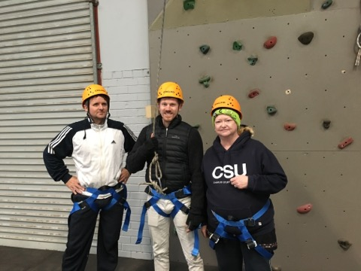
The behaviour of all students is to be commended on this excursion, as they were respectful and well-mannered throughout the two days; it is always a pleasure for us teachers to run a stress-free excursion with such great students, and we thank them all. We are also sure that the students that came back from this camp were not the same ones that we took on Thursday morning, and that they are a lot more knowledgeable about various aspects of psychology and are better equipped to handle the many stressors the adolescents are bombarded with on a daily basis. Finally, thank you to the parents that supported their children by giving them such an invaluable opportunity to attend this camp, and a huge thank you to Michael, Bree and the team at Camp Borambola; we look forward to seeing you again in 2020.
Regards
Claud, Liam, David and the Psychology Team

Languages

Mandarin Awards Presentation
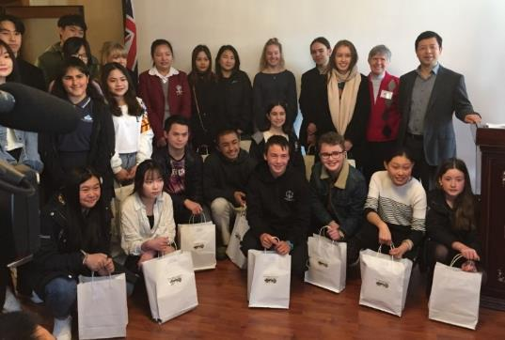
On Sunday 11 August the presentation Ceremony for Awards for the best and most improved students of Mandarin were held at the Cultural Office of the Chinese Embassy.
Minister-Counsellor Yang hosted the ceremony for the second year running and it was attended by Meg Owens from the ACT Government’s Education Directorate, Mr Yang’s wife Yafen, Australia China Friendship Society (ACFS) committee members, the Chinese Education Counsellor and staff from the Embassy and international students.
Mr Yang and Carol Keil, President of ACFS, gave short speeches and they were followed by Yafen who sang a beautiful song, a short video on China today and then a brief talk on the Silk Road by Mr Sheng from the News Section of the Embassy. This was followed by the presentation of the awards which consisted of a certificate in a special folder, a letter of congratulations plus a Society bookmark, 2 books and a small notebook which were gifts from the Cultural Office.
Congratulations to Yifei (Flora) W, the recipient of award for the best student of Mandarin and Jay I, the recipient of award for the most improved student of mandarin from Canberra College.
Yaoxiang (Mandarin Teacher)

Indonesian Language
The College is again offering Indonesian as one of our languages of delivery for 2020. Learning additional languages widens horizons, broadens cognitive and cultural experience, and develops communicative and intercultural competence. It also opens up new perspectives for learners, not only in relation to other cultures and languages, but also in terms of their own language and cultural practices.
Learning languages strengthens intellectual and analytical capability and enhances creative and critical thinking. Students develop an understanding of the nature of language (including linguistic and stylistic features), of culture, and of the process of communication. They develop understanding of how values and culture shape world view. Learning languages extends the learner’s understanding of themselves, their heritage, values, culture, and identity. Students develop intercultural capability; they develop understanding of, and respect for, diversity and difference, and openness to different perspectives and experiences. Learning languages contributes to strengthening the community’s social, economic, and international development capabilities.
The new course, recently developed and accredited with the BSSS will be offered at the beginning, continuing and advanced levels, so we are hoping that either current students at the college (who will be able to achieve a minor) or new students in 2020 select the language as one of their courses of study. One major advantage of studying a language at Years 11 & 12 is that the ANU (and possibly other universities) may give additional bonus points to a student’s ATAR to gain entry into the institution.

Business – Illuminate NextGen Business Challenge
The Illuminate Nextgen Business Challenge was a week of business ideas, business planning and perseverance. This challenge was to do with United Nations 10-year international initiative to advance global sustainability. The teams had to design a solution that supports or promotes this initiative.

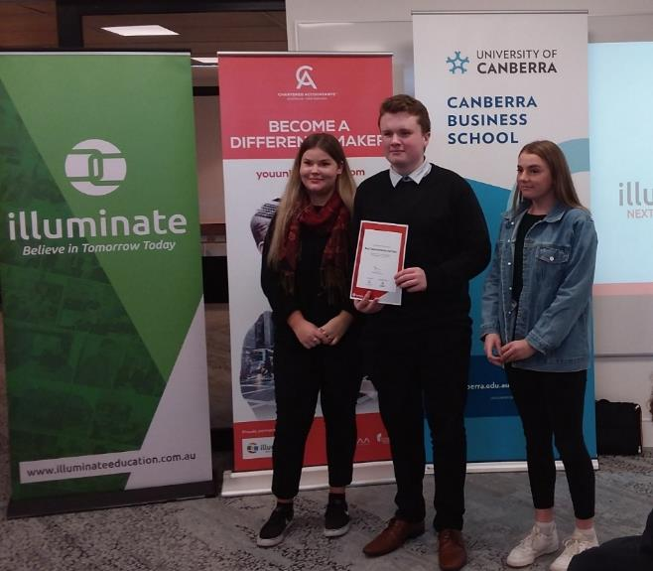
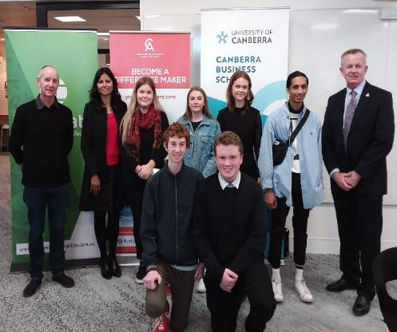
The two business ideas that Canberra College put forward were for sustainable businesses operating in the Canberra region. The idea for Eco-Friendly Outdoors was for a holistic consultancy business that works with clients to improve the sustainability of their garden. The Ecoclique business idea was for a sustainability rating platform that incentivises both consumers and businesses to shop more sustainably. Items in stores can be scanned by users and the sustainable rating of the product transfers to the customer. Eco-Friendly Outdoors won two awards: The Best Short Challenges and The Best Demonstration Hall award. EcoClique won the award for the best Business Idea and the Best Pressure Cooker Submission. Overall it was an exciting and challenging opportunity and we’re all thankful for the chance to learn new business skills and meet new people.
Anthony, Toby and Shannon
Isabella, Lachlan and Mikaela

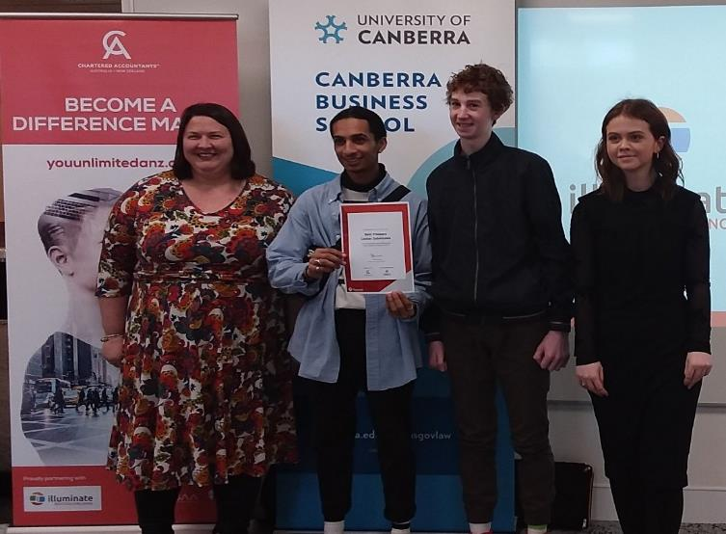
Business – Market Research
Adam Allanson from Orima Research (Australia's leading provider of end-to-end research and data analytics services to the public sector) kindly gave valuable time at Canberra College to present a workshop on market research for students undertaking the marketing unit in Business Studies.
An enigmatic speaker, Adam engaged the students with an die exercise on polling, relating this to the recent federal elections and clarified how the media analyses got it so wrong. Through displayed graphs and comfortable rapport with students, Adam, who has worked as an advisor to the Howard government, lectured economics at ANU and now has many market research projects online, shared his knowledge and provided vocational insights into the market research industry.
After the workshop, students and staff both remarked in discussion on how worthwhile, practical and on target with the curriculum, this session was.
Mathematics

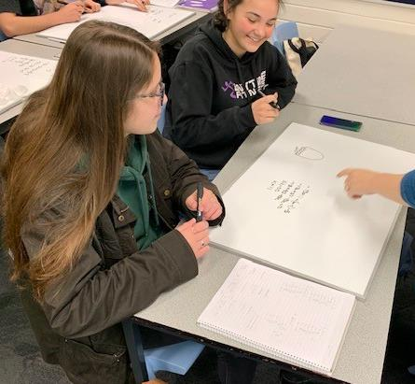
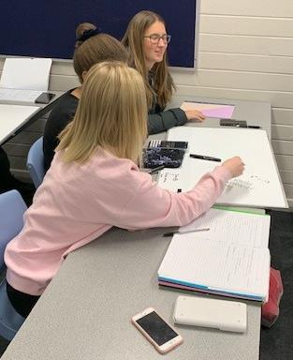
The Mathematics area at Canberra College has been refurbished, with new paint, carpets and interactive whiteboards.
One of our beginning teachers, Simone Gangell, has been using small whiteboards in her classes to encourage group work and collaboration. The students are enjoying this as a different approach to learning.
Shane Barrett is working with a Mathematician in Schools with her year 12 Specialist Mathematics class, during their statistics unit. This enables the students to talk with someone that uses statistics daily in their job and see where they may head with statistics into the future.
Students working on small whiteboards
Our Mathematics students continue to be enthusiastic supporters of enrichment activities and have again been busy taking part in the UNSW Mathematics Competition held in June and the Australian Mathematics Competition held in August.
For the UNSW Competition, we had 11 students prepared to attempt this very challenging competition for the fourth year in a row. This competition is a 3-hour exam comprising six questions which require a very high level of conceptual thinking. This requires a large commitment from these students, and they should be congratulated for their willingness to challenge themselves with this competition. This year Lachlan Huang gained a credit certificate prize, but all students were congratulated ‘on their fine efforts as the competition is designed to test mathematical insight and ingenuity rather than efficiency in tackling routine examples. Their achievement in competing on a state-wide level should be noted.’
Below is a sample question:
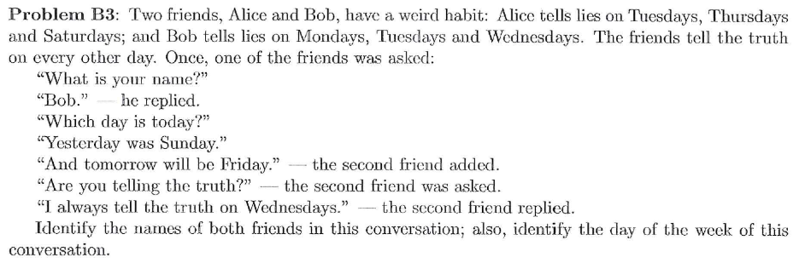
We also had 20 students from both Year 11 and Year 12 participate in the Australian Maths Competition on the 9th August. We received their results this week and they have again produced excellent results with 3 High Distinctions, 9 Distinctions, and 6 Credits. These are excellent results for our mathematics students. Year 12 students Lachlan Rowe and Lachlan Huang and year 11 student Luka Rolfe gained High Distinctions. Luka was identified in the 100th percentile for year 11 students. All our students are to be congratulated for such excellent results in this competition.
All students should be congratulated for their enthusiasm and willingness to put in time and effort in these enrichment activities.
Shane Barrett - Mathematics Faculty

Science News

RACI Titration Stakes ACT Final
12 September 2019, one Canberra College team participated in the RACI Titration Stakes ACT Final competition at the Australian National University. Jessica Booth, Aithne and Emma Woodford were the team members who spent three hours of focussed and precise titrations until 8pm. Jessica Booth and Aithne were awarded silver medals, and Emma Woodford was awarded a gold medal for their individual performances. Congratulations to the students who participated in this challenge and thanks to the Chemistry teachers who devoted their time and efforts to assist the students in their preparations for this important event.
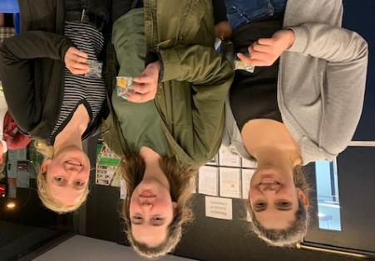
Jessica Booth, Emma Woodford and Aithne
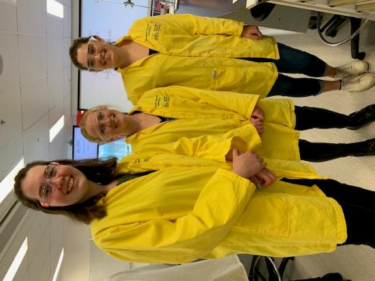

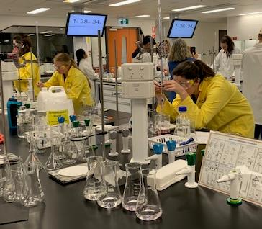

Emma Woodford, Aithne and Jessica Booth

Wellbeing Expo

Wellbeing Expo happening in Week 10!
Our Annual Wellbeing Expo will be held on Monday of Week 10, starting at 12:45pm. The Expo will begin with students attending one of 3 different wellbeing related education sessions/presentations. All students have been emailed the link to sign up for their chosen session and should do so ASAP. We have the following three presentations available:
AUSTRALIAN FEDERAL POLICE: Partying Safely - Alcohol & Drugs (a policing perspective) - This session will include case studies relating to the harms associated with alcohol and drug misuse; footage/discussion of assaults investigated within the Canberra CBD; tips for ensuring a safe night out (including who to go to for help and assistance)
LIVINWELL Presentation - LIVIN is all about living your life at the top and breaking the stigma around mental health. Connecting, supporting and encouraging one another to talk about their feelings and challenges because “It Ain’t Weak to Speak”. This session will include content on building self-efficacy (both helping yourself and helping others) and encouraging help-seeking with a blend of lived experience and mental health training from young facilitators.
CC ALUMNI: Three former Canberra College students will talk briefly about surviving college and moving into adulthood in a panel discussion/forum setting. Students are invited to bring along questions to ask the former students about wellbeing into adulthood.
After the education sessions students will head down to the CC Cares Boulevard for a huge range of festive activities. There will be a free sausage sizzle, band performance and a range of wellbeing activities that promote fun and good mental health. Activities include a jumping castle, tea ceremony, colouring in, communal puzzles, giant Jenga, Twister, Yoga, tactile mindfulness, table tennis, giant volleyball, handball competition, make-up sessions and hand massages. We can’t wait to enjoy the day!

Get Involved at CC

Our newsletter does a great job of highlighting the various activities that the college is engaging in at particular times of the year. There is so much on offer around the school throughout all year round and we thought it’d be a great idea to collate all of these extra-curricular activities under the banner of ‘Get Involved at CC’! Our plan is to more actively promote the collective range of activities we offer through the newsletter, student meetings and other avenues. Our aim to get more students than ever engaging in activities around the school that help build confidence, community and connectedness. Have a look at the HUGE list of activities available for students to be a part of:
ACT Constitutional Convention, ACT Debating Competition, ACT Parliamentary Debates, ANU Maths Day, ACT Mock Court (Mock Trials) Competition, ANU SOAD College, Architecture Guest Talks, Art Exhibitions (end of each term/semester)*, Book Club*, Career Pathway events*, Chess R Unit*, CodeQuest Programming Competition, Cyber Security Challenge, Dance events (Dance Festival, Step Into the Limelight Gala Showcase, Come Alive Festival and more), Digital Tech Day Farrer Primary School, Drama and performance events (Drama Productions Acting Up!, Drama Festival Canberra Theatre, Step Into the Limelight Gala Showcase, Come Alive Festival), Floriade/Conservation ACT Volunteering, Futures testing week alternative program, Futures T- Shirt Enterprise, Grok Programming Challenge, Gender Sexuality Alliance*, Hospitality Culinary Federation Competition, Hospitality events (various events throughout the year)*, Interact Rotary Club*, Intercollege Sport*, Jazz Band*, League of Legends (collaborative program with Headspace), Lifeline Book Fair Volunteering, Limelight Exhibition, Maths Camp at Wombeyan Caves, Maths Competitions (CAT, UNSW Maths Competition, AMC, ICAS Maths Competition), Media/Film events and exhibitions (end of each term/semester)*, Model United Nations, Music events (Merimbula Jazz Festival, ACcENT concert, lunchtime concerts for Music Industry students), NextGen Illuminate Challenge (Business/Commerce Competition), NGA Summer School Scholarship, One Day Sports Carnivals (throughout the year)*, Photography exhibitions (end of each term/semester)*, Photography R-unit*, Pines Living Aged Care Volunteering Program*, Plan Your Own Enterprise Business Competition, Pre-med R-unit*, Psychology Camps (Sydney Year 12 Term 2 and Borambola Year 11 Term 3), Reconciliation Garden*, Relay for Life Fundraiser, Science Competitions (Biology, Chemistry and Physics Olympiads, Chemistry Quiz, ICAS Competition, Titration Competition), She Leads (YWCA) Conference, Strength and Conditioning Training (R Unit)*, Student Voice (School Leadership Group)*, UNSW Programming Competition, Vegetable Garden*, Work Experience, Young ICT Explorers Competition…
The list could go on! Everything marked with an asterix (*) runs throughout the year so students can get involved at any time.
We’ll be showing this to students (with extra information including when activities run and the organising teachers) in an effort to further support students to ‘Get Involved at CC’!

Student Services

The Student Services Teaching team
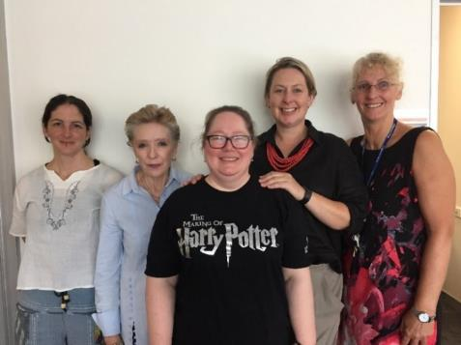
Student Surnames A-F Kim Thomas
6142 3332
kim.thomas@ed.act.edu.au
Student Surnames G-K Susan Johnson
6142 3334
susan.johnson@ed.act.edu.au
Student Surnames L-R Jo Lee
6142 3331
jo-anne.lee@ed.act.edu.au
Student Surnames S-Z Rachel Regan
6142 3286
rachel.regan@ed.act.edu.au
Executive Teacher Kate Fox
6142 3333
kate.fox@ed.act.edu.au

Futures

Term 3 is flying by and Futures students have been working hard across all curriculum areas. A new Work Skills class has been created with a vision to improve students’ work and communication skills. CCCares have been integral in supporting this process with our students conducting stocktake of storerooms, creating craft activities for the childcare rooms and assisting with preparatory work for the café. Great to continue our close working relationship with CCCares.
The most exciting news for Futures (and the college as a whole) is the purchase of a Direct to Garment printer which will form the core of a new Futures Enterprise. Students will be responsible for the creation of the business, interacting with clients, printing of goods (such as t-shirts, tote bags, aprons, tea towels) and delivering product to clients. We are working closely with the business, graphic design and textiles faculties to create a cross faculty and inclusive business for all students. If you have any uniforms or promotional garments you need printed, please get in touch with us!
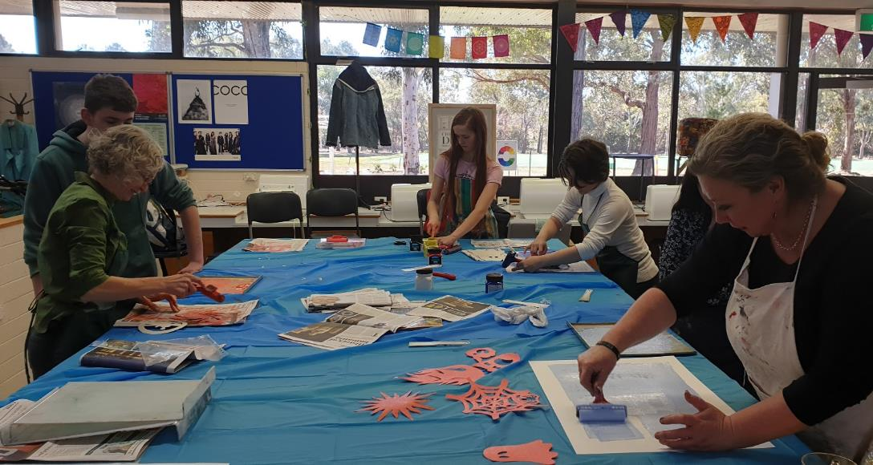
We had Viktor Halas join our agriculture class and conduct a lesson on using microscopes which the students all found very exciting. Art students participated in a printmaking workshop and they will also be joining the Art Exhibition Wednesday Week 10.

Humanities

Visiting Author
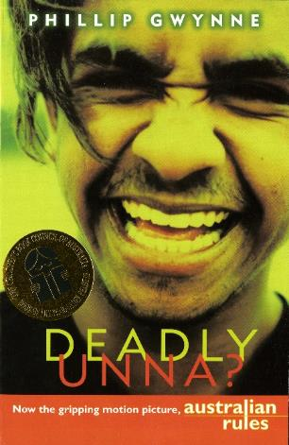
We are very excited as Phillip Gwynne, author of the novels Deadly Unna and Nukkin Ya, will be visiting Canberra College on October 18, in the first week of term 4. Deadly Unna was made into the feature film, Australian Rules for which Gwynne won an AFI award. His presentation will be open to all students and will be advertised in the I-Group notices.
Deadly Unna

English and Literature
This semester year 11 english students have been studying a range of different texts which look at all sorts of issues and themes relating to the human condition.
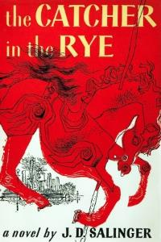
These have included essential english study of Tom Wright’s play, Black Diggers, which looks at the contribution of lives and deaths of approximately one thousand indigenous soldiers who fought for the British Commonwealth in World War One.
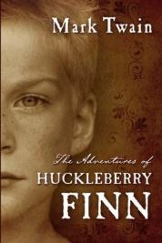
In the Year 11 and 12 english and literature courses students have been studying a range of different text types from across the world. These have included the plays The Crucible, Cosi, The Doll’s House and Waiting for Godot. Novels studied across the faculty this semester have including Huckleberry Finn, Kafka’s Metamorphosis, The Catcher in the Rye and The Life of Pi. Short stories studied this semester have included the work of authors Murakami, Angela Carter, Edgar Allan Poe and Charlotte. Perkins-Gilman.

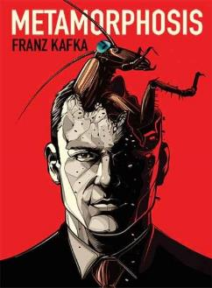
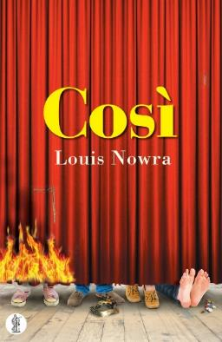
Philosophy (Ethics)
This semester in philosophy, we have been studying ethics. Our overarching question for the unit is: “Why be moral?” We have looked at duty ethics, which involves making moral judgements about a person’s actions or behaviour based upon intention. To contrast with this, we examined consequentialist approaches to judging a person’s actions or behaviour. The most well-known consequentialist approach to actions and behaviour is utilitarianism. Put simply, a person’s actions or behaviour are judged based upon the consequences of their actions or behaviour. If an action or behaviour results in happiness for a majority of people, then the action or behaviour (regardless of the intention) can be deemed to be moral. Most recently, we have been discussing the notion of virtue, and how the ancient greek philosopher, Aristotle, believed that we should strive to be of virtuous character. We read, discussed and critiqued some of the arguments put forward by Aristotle. Following on from this we, as a class, came up with a list of character traits that we considered to be reflective of a virtuous individual. They are as follows: kindness, self-awareness, unprejudiced, patience, generosity and self-control.
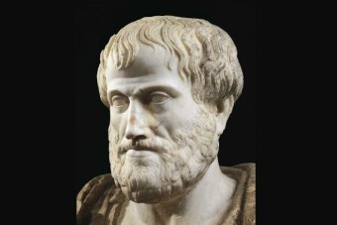
Aristotle
Many of the ideas from what are, historically, ancient times are enjoying a resurgence in popularity today. It has been a real pleasure to see this year’s year 11 philosophy (Ethics) students engaging with, contemplating, critiquing and perhaps even applying some of the ideas we have been studying this semester in Philosophy.
Adrian Poole

History
At Canberra College students can choose from three different history courses including Ancient History, Pre-Modern History and Modern History. In Ancient History students have been looking at either Pompei and Herculaneum or the Julio Claudian Empire. In Pre-modern History they have been engaged in either a study of absolutism, looking at Tsarist Russia and Peter the Great or a study of Heroism, Stories, Myth and Social Control looking the role of Robin Hood and King Arthur in English Nationalism. In Modern History students have been engaged in a study of the Cold War era following World War Two.
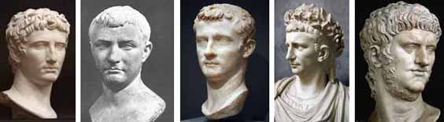
Julio claudian emperors

PE

We have had a busy and very successful term 3 winning the trophy in the girls’ soccer, ultimate frisbee and boys’ badminton and finishing second in the mountain biking! Highlights below.

ACT Colleges Ultimate Frisbee Gala Day- trophy winners!

Friday 6 September at Deakin ovals.
Team 1 played valiantly, with great enthusiasm and continued to improve as the day progressed. Team 2 were absolutely outstanding, undefeated in all of their round games and then went on to win Lake Tuggeranong (7-5) after being down 1-5 at the halfway point, a really inspiring comeback. They were then hugely successful in the grand final against Dickson College, a wonderful effort (though not without drama - one of our best players, Annaliese Pratley, did get hit in the nose with a frisbee which required a visit to emergency, she was such a trooper).
Please congratulate all our players for excellent sportsmanship and performances.
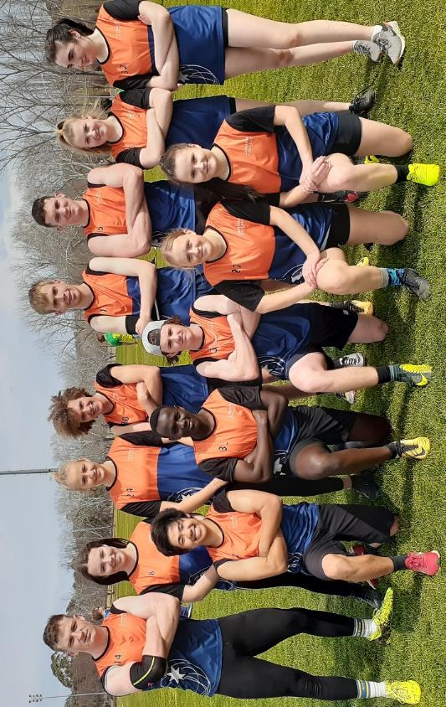
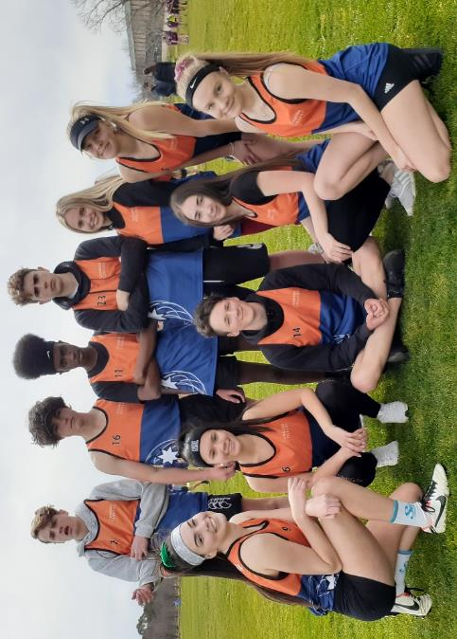
The teams were as follows: Team 1 - Abby Costin, Lily Yap, Jameika Maddock, Mia Hubble, Robyn Rosenow, Renee Carter, Riley Bacon, Ruben Cook, Matt Read, Angus Mills, Samatar Mohamed and Matt Higgins. Team 2 - Bella Cremer-Harvey, Megan Wilkinson, Annaliese Pratley, Freya Boustead, Tara Clogg, Kira Wright, Ronin Campbell, Alex Young, Yuta Leffers, Alex Sangah, Oliver Davies, Will Dodds and Jasper McIntosh.
Frisbee team 2
Frisbee team 1

ACT colleges girls Soccer competition

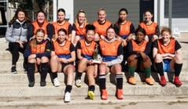
Trophy winners!
Our girls’ soccer team competed in the ACT colleges Soccer competition on the 6th August. They played 5 games straight, went into the GF undefeated and won the trophy! An amazing achievement, and possibly for the first time ever?
It was my absolute pleasure to coach such a committed, skilful group of girls who managed to have fun and display outstanding sportswoman ship throughout the day.
Congratulations to the following students:
Ella Brown, Sharon Chao, Laura Croft, Paige Davis, Claudia Garner, Amelia M, Charlotte Mueller, Kundai Mutambara, Theresa Nguyen, Zoe Taylor, Hayley Taylor-Young, Kylie Webber.

ACT Colleges Badminton competition 23rd August

BACK TO BACK BADMINTON CHAMPIONS!
Canberra college convened this event for all colleges with the help of Laura’s Sports Development at ANU. After a hectic day of competition, our boys team finished the day as undefeated champions of the boy’s division. The team only lost a total of 2 sets during the pool stages to then beat Gungahlin 9-0 in the final to defend their title as the premier Badminton school in Canberra. This is the second time we have been crowned champions after we won last year too.
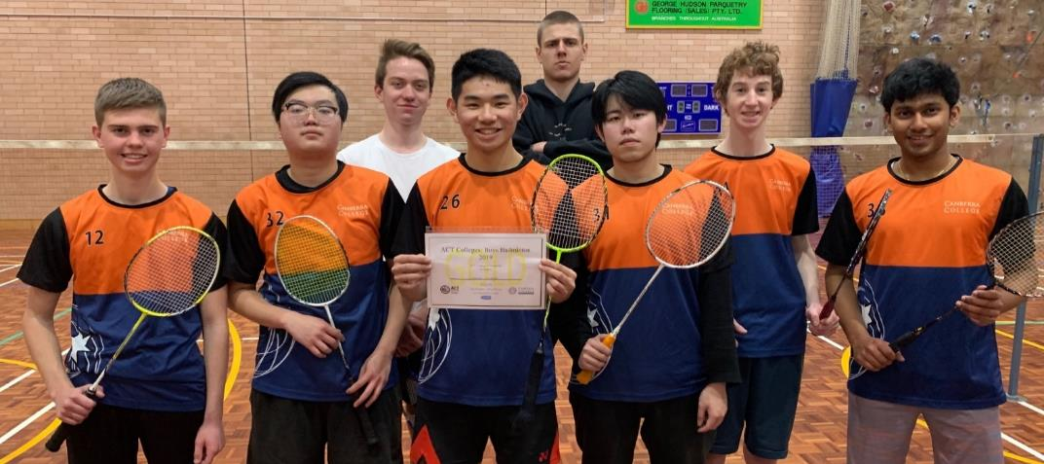
Students involved on the day and should be congratulated on their efforts were: Jacky Mai, Leo Ng, Toby Zhang-Mai, Toby Clarke, Cameron Pike, Manish Rasalinkam, Jack Castles and Joel Foyste.

ACT Mountain Biking Championships 30th August- 2nd place!
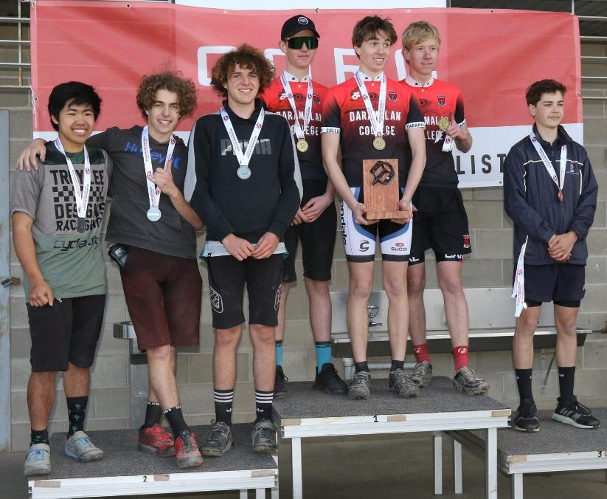
Our boys’ team of Yuta, Jasper and James represented the college in this event finishing in 2nd place! Congratulations!

Snow Sports
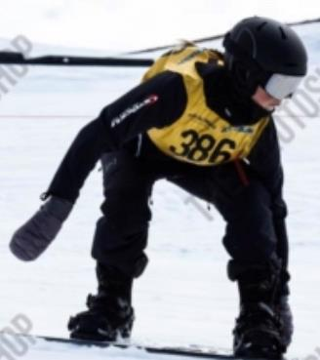
Amber Essex has been competing in the Snow Sports Interschools Competitions throughout this term with some great results. Recently, she finished with a 1st in Snowboard Cross and 3rd in Snowboard Giant Slalom at the Northern Interschools Competition. She then qualified for the Australian Nationals on 5th September representing Canberra College on the big stage. Amber finished 2nd place in snowboard cross and 4th in snowboard GS. Congratulations on this great achievement Amber!
Amber Essex

Intercollegiate Sport

Mixed Oztag
The Mixed Oztag team has been competing in the ACT Colleges Oztag Competition at Erindale College on Thursday afternoons. We had a great time and the social buzz of competition was amazing to see amongst all schools. Erindale were the winners that will go through next week to play the winner of the Northside competition next week. Students who were part of this team include: Will Dodds, Joel Dodds, Jack White, Eamonn Kennedy, Tyler Nguyen, Seb Marwick, Nina Sikoulabot, Sia Sekona, Tilly Tivalu, Kyle Deacon, Haedyn Elson and Hayley Taylor-Young.
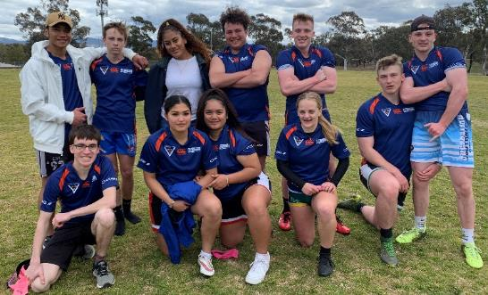

Boys and Girls Volleyball

One day Competition Friday 16th August
Our girls team bonded very well, had a great time and improved throughout the day despite losing most of their games. The boys team played consistently to make it through to the semi-finals.
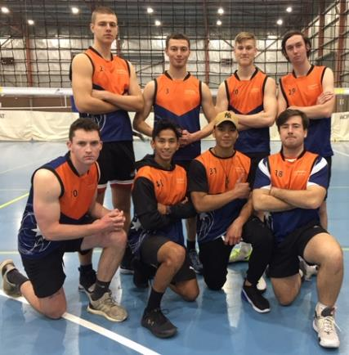
Mixed Oztag

Intercollegiate Volleyball
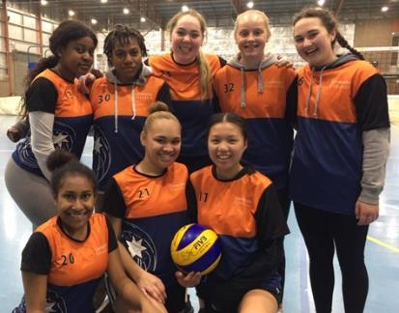
Our Volleyball teams have been competing each Thursday afternoon this term. The boys played consistently throughout the season buy narrowly missed out on the finals. Our girls made it to the semi-finals played at the AIS in week 8.
The teams:
Girls team-Tylaina Lauvao, Sharon Chao, Delilah Laori, Tina Wii, Angela Van der Riet, Imogen Parker, Tupe Ulberg, Ella Brown, Kundai Mutambara.
Boys team- Ec Teo, Riley Hawker, Liam Whitby, Khaled Abbass, Ronin Campbell, Jack Castles, Matt Pryor.

Outdoor Ed
Outdoor Education students have been busy completing their first aid certification and pack rafting skills at Pine Island and at Tumut. The SCUBA program is heading to Vanuatu in October and then completing the PADI Rescue diver training.
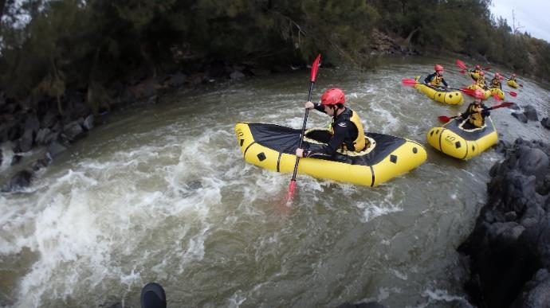

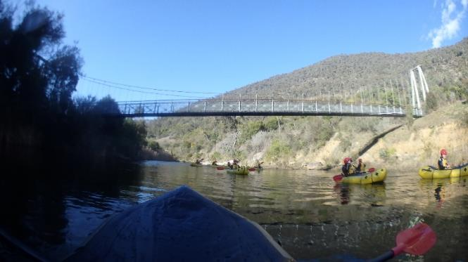

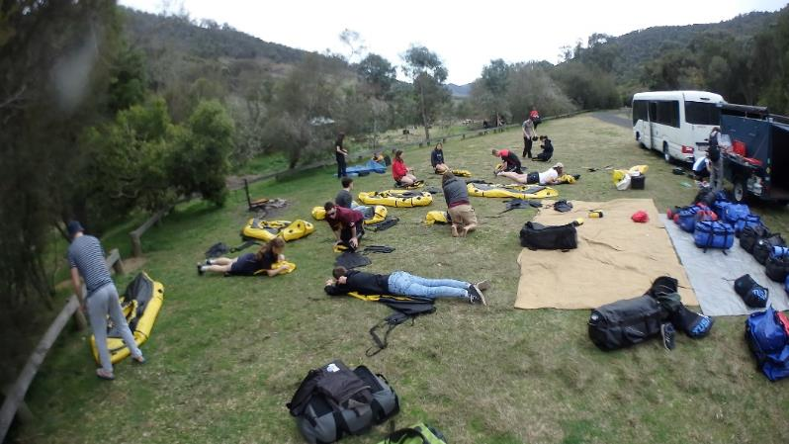

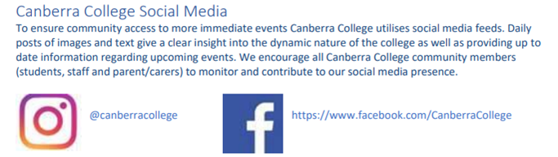
CCCares

Hurrah for Hair
Three of our stylish hair stylists, Amy Ashcroft-Bryant, Paris Jackman and Stephanie Lowey surpassed all expectations on Saturday 31 August when they won the first three places in the World Skills in Hairdressing competition held on campus in the CCCares salon. These students with quality industry skills were watched by four external judges. As winners in this local competition our three ASBA students, taught by our incomparable Radha Beessoo, could progress to national and even international competitions.
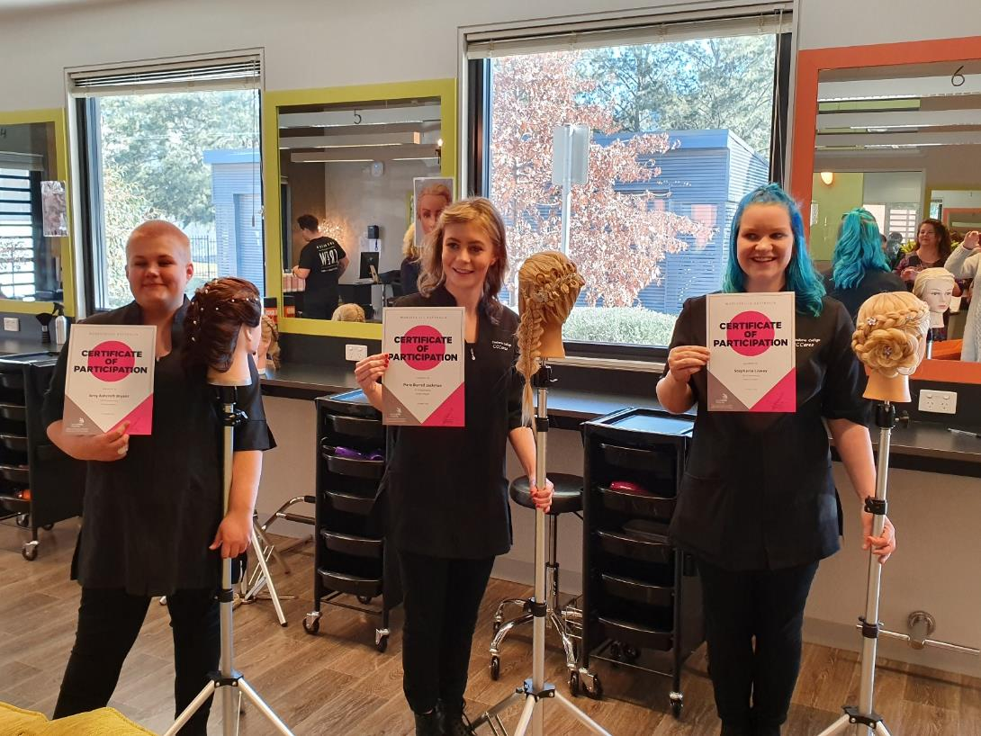

Canberra College ~ Important Dates Term 4 2019
Date | Event | Details
Monday 14 October | Year 11 student meeting | 12:45pm – 1:15pm
Monday 21 October | Year 12 student meeting | 12:45 – 1:15pm
Monday 11 November | Year 11 student meeting | 12:45pm – 1:15pm
Monday 18 November | Year 12 student meeting | 12:45pm – 1:15pm
Wednesday 20 November | Last day of formal classes
Thursday 21 – Tuesday 26 November | Tests
Friday 29 November | Feedback Day | All day
Monday 2 December | Work Experience Week
Tuesday 3 December | Year 12 Breakfast Celebration | 10am
Wednesday 4 December | Year 12 Formal | 5:30pm
Friday 13 December | Reports emailed out
Monday 16 December | ATARS posted in student services
Thursday 19 December | Year 12 Graduation | 11am
Administration: 2 Launceston Street, Phillip ACT 2606
E: info@canberrac.act.edu.au W: www.canberrac.act.edu.au T: 02 61423288

